BRIDGE DESIGN TITLE

PLEASE DO NOT USE MORE THAN 2 LINES
Grete MUELLER  Professor  Technische Universität Berlin  Berlin, Germany  grete.mueller@tu-berlin.de | Hans MEYER  Civil Engineer  Meyer and Partners  Stuttgart, Germany  hans.meyer@mrpartner@com

Participants wishing to present a design for one or more footbridge(s) for the theme Footbridges for Berlin are invited to submit a “paper” using this template.

SUBMISSION
The idea is that you choose one out of six proposed locations for your bridge design in Berlin. The “paper” of your design should be no longer than three A4 pages in landscape format using this template. Please note, that we want to collect all designs in a book that will be published in DIN A4 landscape format.
You are completely free to choose the layout of the three pages using text, photos, sketches, renderings etc., however please maintain the headline with FOOTBRIDGE 2017 Berlin.
Since this is not a design competition and the city has no immediate intention to build, your design does not have to be strictly buildable, but innovative. Still, we have tried to provide sufficient information so that you can also prepare a fully feasible solution. Do not forget to tell a story.
The “paper” of your design shall be submitted as a pdf-file by the deadline on 7th April 2017. It should include the name and e-mail address of the authors. Please upload the file using the Converia online system https://express2.converia.de/frontend/index.php?folder_id=841.
Please use this filename: BD_First Author Surname_Paper ID.doc (example: SV_Mueller_261.doc)
The bridge design “paper” ID is a number ascribed to abstract submission and can be found in your Converia user account. In this example the unique Paper ID corresponds to 261. Please note that hard copies, e-mails or fax submissions will not be accepted.

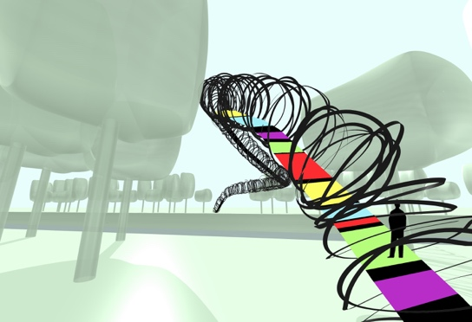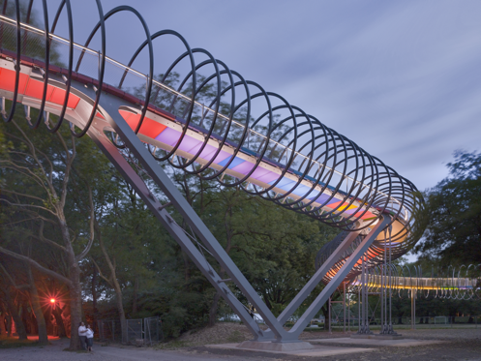
Figure 1: Bridge Sculpture “Slinky springs to fame”, Oberhausen, Germany, 2011. a) Sketch by Tobias Rehberger, b) Photo by Roman Mensing

